Lab 11 manual: Thin lenses and lens equation
Dr. D. Beznosko
4/19/2026
For PHYS 1112L only. Lab outcomes: reciprocal relationships, object-image.

Abstract
The lens equation is used to determine the position of the image relative to the object and the lens properties. Magnification is also found. Different methods can be used to measure the lens’ properties.

Introduction
The refraction is also at the base of lenses and lens equation. When were the first lenses produced? What are chromatic and spherical aberrations? Can you find any more examples and practical uses for lenses?

Experimental Setup
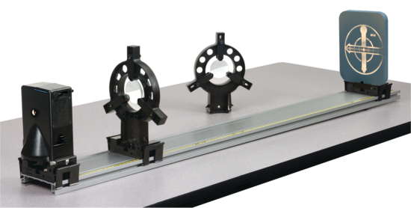
The experimental setup in Figure 1 shows the optical track, image source (object), a screen and a lens. Laser and acrylic block are now shown.
Lens
Screen
Image source
Optical track
Figure 1: The experimental setup schematic.

Procedure
Listen to laser safety very carefully. Never look at the laser directly (the light emission point), never point it at any person or reflective surface!!
Three methods will be used to determine the focal length of the lens (a lens is provided).
Method 1: Parallel beam shift.

A laser beam is aligned to pass through the center of the lens. A slab of transparent material (acrylic block) is then rotated in the beam in front of the lens. Refraction in the slab produces beams parallel to the central axis beam. Since parallel rays converge at the focal point of a lens, the distance from the lens to a screen can be varied until the rotation of the slab produces no motion in the position of the laser beam on the screen. When this condition is met, the image distance is equal to the focal length.

Screen 1
Acrylic block

Screen 2
Laser
Optical Track
Optical axis
Figure 2: Method 1 setup.

Show in the report that acrylic block indeed creates parallel beams!
As shown in Figure 2, if the screen is not at the focal point, such as Screen 2, the parallel beams will not be converged to a point. Thus, if you move the acrylic block around, the laser dot at the screen will appear to be moving. If the screen is at the focal point, such as a Screen 1, then the point will remain stationary.
By moving the screen, find the focal distance. What are the measurements errors here – consider these as systematic (the lens and screen position accuracy?). repeat 5 times, take the average and stdev – treat this as a statistical error. Combine errors.
Method 2: Measurement of the object and image distances.
Place the image source such that the image is at 0.0 cm (or assume its position at 0 and adjust all other positions). Place the lens under testing at distances as indicated below. Record the image distance from the lens. Note all errors. Do the 5 measurements for only one distance. Combine errors and reuse for all values.
Note that you may get a lens with smaller or larger focal length. Depending on that,
- For the lens with smaller focal length (100mm), place it at distances between 12 cm and 50 cm from the object. Choose 10 positions that are approximately equally spaced.
- For the lens with larger focal length (200mm), place it at distances between 26 cm and 80 cm from the object. Choose 10 positions that are approximately equally spaced.
Method 3 (optional):
The easiest method of determining focal distance is using the object at infinity (or a good approximation of it). Given weather and time considerations, choose one lens and take the setup outside of the lab (corridor or a parking lot, etc.). Image the distant object on the screen. Record the distance. Repeat 5 times, combine the errors.

Experimental Data
The results of the measurements should be organized as Table 1 or similar. Think about how to organize the tables. The error can be listed in a different column or as value ± error unit. Don’t include all data values here, only relevant means, stdev etc.
Table 1: Experimental data.
Quantity name | Measured value, units
Distance to object, m | Distance to image, m

Provide description about each entry as needed, don’t just leave the table without text in this section. Organize well so that data takes up less space, but everything needed is included.

Theory
Consider equation 1 that described the thin lens law:
$$\frac{1}{f}=\frac{1}{p}+\frac{1}{q}\left(1\right)$$
with $f$is the focal length of the lens, $p$ is the object distance from the lens, and $q$ is the image distance from the lens. Always use equation editor and number the equations so that they later can be referenced as eq. 1 or equation 1. You will need other equations and/or derivations in this section.

Extra credit - show the derivation of thin lens law in sufficient details. There are multiple derivations – use the one you like most and it is easiest one to understand.

Analysis
Methods 1 and 3:
Find the focal length and compare with nominals written on the lens and the results from Method 2 as well.
Method 2:
For each lens data, plot … wait, equation 1 is not linear. We can rewrite it in a form of $f=\frac{pq}{p+q}$ and see what needs to be plotted so that focal length is the slope. Find the error bars for the x and y axes. Find the slope and compare it with the results from other methods and nominals within errors. (Hint – remember all other things to find as with any plot!)

Conclusion
Comment on your result and the methods used to find it. What did you learn in performing this measurement? Where else can it be used? Can it be improved?

